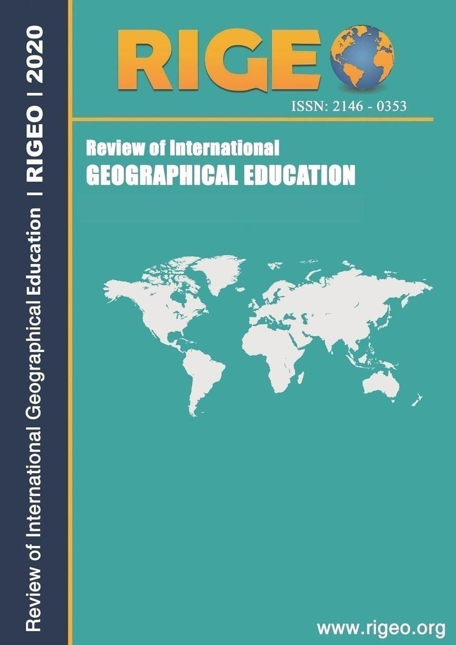

Guest editors’ introduction: Building a radical food geography praxis

Jongwon LEE1Ewha Womans University, Seoul, SOUTH KOREA

**Abstract:** The articles included in this special edition were compiled during a turbulent 2020, which exposed several inequalities in food systems. Poverty and food insecurity have worsened throughout the worldwide COVID-19 epidemic and its associated economic downturns, particularly in minority and Indigenous populations (Bauer, 2020; Perry and Harshbarger, 2020; Roberts, 2020). People who work in the food system and are employed in a precarious manner often live paycheck to paycheck; this is exemplified by the fact that many restaurant employees have lost their jobs as a result of closures and are now struggling to meet their basic needs (Dickinson, 2020). Furthermore, despite insufficient worker safeguards against the new coronavirus, migrant workers are compelled to return to farmlands, dairies, and meat processing industries (Beaumont, 2020). There will be food shortages in certain regions of the globe since the global food trade networks that the dominant industrial food system has adopted are ill-equipped to deal with disruptions like this (Chin, 2020). All of these long-standing and worsening inequalities have their roots in the capitalist system's inherent racism, sexism, and colonialism, which in turn prevents individuals and communities from establishing food systems that are fair and sustainable (Freshour, 2017). In their battle against systemic oppression and police brutality, social movements have brought attention to the intersection of food insecurity with power dynamics, which disproportionately affects Black, Indigenous, and People of Colour populations (Nittle, 2020).   
Various approaches to radical food geography practice are shown in this special issue. Standing at the crossroads of radical geography and food systems study, this praxis offers both theoretical and practical insights into the fight against oppressive food systems and the creation of more just and sustainable food systems for the future. These methods are based on an examination of capitalism exploitation, oppression, and power relations in different historical contexts. However, they go beyond these theories and use their knowledge to research, activism, or both in order to effect change in food systems. Crucially, different people's perspectives on the historical, cultural, and philosophical systems that influence the pursuit of change and by whom it is undertaken form the basis of such practice.

**INTRODUCTION:**

At the 2019 American Association of Geographers (AAG) Annual Meeting in Washington D.C., a workshop called "Radical Food Geographies: Connecting Knowledges, Cultivating Practices, (re) Imagining Governance" was held. The three guest editors of this special issue, along with a group of other academic and community-based collaborators, co-organized the workshop, which drew over a hundred participants from academic and community-driven spaces, who gathered to discuss the future of radical food geographies.1 It expanded upon prior efforts by the Geographies of Food and Agriculture Specialty Group and the Food Justice Scholar-Activist/Activist-Scholar Community of Practice, which included the guest editors of this special issue, to bring together scholars and activists working in community-based food systems. These efforts included organising field trips, roundtable discussions, and panels at AAG meetings. Workshop participants aimed to better understand how community-based activists/practitioners, policy makers, civil society organisations, and geographers can work together to promote food sovereignty and justice, rather than just attending academic conferences or going on field trips. This was done to foster more meaningful exchanges between different social actors regarding how to collectively work towards systemic change.   
In our first ideas for the workshop, we reached out to individuals in academic and community settings, particularly in the Washington, D.C. area, to imagine a day where people could share and receive information, ask each other questions, and generally have a good time.  
continuing as before, and investigating potential avenues for partnership. Participants were provided with a report that we had prepared using the conference notes (Radical Food Geographies Organising Collective, 2019) after the event. Scholars, activist-scholars, activist-scholars who presented or participated in the workshop, and activists whose work influenced that day's talks were all invited to submit to this special issue by the guest editors. We purposefully sought writers working from a range of viewpoints, initiatives, and ideas rather than publishing a wide call for papers. Our goal was to increase the diversity of research, which we believe adds to the emerging concepts of radical food geography praxis (see Hammelman et al., 2020). We aimed to include writers whose contributions to the field of food systems are in line with or directly engage with radical geographies; this means that their work will focus on marginalised communities' concerns (such as Black, Indigenous, and Latinx geographies), will prioritise diverse ways of knowing, and will actively engage in socially relevant change initiatives. We are certain that there is a larger community of radical food geographers working both within and outside of academia who were either unable or unwilling to attend the workshop in Washington, DC, and with whom we do not have any formal connections. Due to its limited scope, this special issue aims to spark discussion rather than provide all the answers on the future of radical food geography practice.   
While trying to establish this foundation, we ran across a few roadblocks that are representative of the larger difficulties of engaging in radical research. To begin, although there is a great deal of diversity in the authors' perspectives within North America, the majority of the articles in this special issue centre on case studies from that region. The origin of this conversation may be traced back to its inception inside the AAG, a North American group that is hosting an event in the Americas. However, this is also a reflection of the dominance of English-language scientific publications from the Americas and Western Europe. Because of this, important and small practices from different parts of the globe that are necessary for comprehending people's everyday lives and forms of resistance are becoming less visible. Therefore, we consider this special issue a springboard and acknowledge the necessity to incorporate a wider range of academics and scholarly approaches in these debates. Furthermore, as white academics employed by North American universities, our perspectives impact our ability to solicit contributions and review papers, even though we are committed to unlearning white supremacy. All three of us are guest editors and teach and research within the framework of community-engaged scholarship in various countries and regions of the world. Some of us also hold tenured or tenure-track jobs, so we have the time and money to devote to this project. Lastly, this special issue was formed by academic scholar-ship norms that demanded conformity rather than disruption of hegemonic norms involving interactions with literature and theory, research techniques, and publishing timeframes. We acknowledge these constraints and urge additional publications to publish research from underrepresented groups and issues.   
  
role in creating significant research in the field of radical geography.   
"Towards a radical food geography praxis: integrating theory, action and geographic analysis in pursuit of more equitable and sustainable food systems." is the review article that Reynolds et al. (2020) write as the first piece of the special issue. In this article, we explore how the fields of radical geography and food systems research may inform a radical food geogra-phy praxis. We argue that this kind of praxis involves not just geographical study but also theoretical investigations of oppressive power systems, as well as direct action to effect social change. In the essay, we extend an offer to work together on a radical praxis project to create food systems that are more sustainable and fair. The following articles take a more empirical approach to these themes, drawing on the knowledge and experiences of scholar-activists and activist-scholars on various food system issues.   
After what we hope will be an introductory discussion of radical food geography practice, a number of talks address issues related to land, land dispossession, and current movements for food justice as a means to achieve land justice. Gilbert and Williams (2020) go into the multi-faceted issues of racial justice, land justice, and healing in their article "Pathways to reparations: land and healing through food justice." The authors find common ground between food justice programmes and social movements seeking reparations. Reparations demands for equitable land access and opportunity for healing from intergenerational trauma may be met via food justice initiatives to reform oppressive structures, which they view to be an important alternative. This work by Brown et al. (2020) titled "The history of the land: a relational and place-based approach to teaching (more) radical food geographies" further emphasises the significance of land interactions. The writers consider their own personal history and the profound connections to the land in order to generate the critical thinking required to generate anti-oppression work in alternative food programmes as they offer a popular education approach used by Grow Dat Youth Farm in New Orleans. The authors acknowledge the historical divide between Indigenous communities and enslaved people, who have worked the land, and white people, who have decided what is acceptable land use and ownership from the time of colonisation to the present day. They begin to envision futures based on new relationships of land access, redistribution, and reparations.   
In order to achieve food justice, several of the articles analyse both the effects of international political and economic regimes (such as gentrification and immigrant labour regulations) and the daily connections that fight against these regimes. 'D.C. is mambo sauce: Black cultural production in a gentrifying city' by Reese examines the racial, socioeconomic, and power dynamics in Washington, DC's rapidly changing neighbourhoods through the prism of mambo sauce. Specifically, she delves into the cultural appropriation of mambo sauce and how it transitions from posh establishments to takeaway joints in Black working-class neighbourhoods.   
bistros in areas that have recently experienced gentrification. According to Reese, mambo sauce is a product of Black culture that facilitates belonging and, simultaneously, serves as a marketing ploy for newcomers to the area to visit fancy restaurants and avoid the "real DC" altogether. "'Because they are connected: Linking structural inequalities in farmworker organising," by Sbicca et al. (2020), examines the connections between migrant, Latinx, and women-of-color resistance movements and the many kinds of farmworker exploitation in the US. By focusing on Community to Community Development (C2C) in Washington state, they show how farmworkers are organising on the radical front lines of intersectional issues, particularly those including class, immigrant status, gender, and racism. In order to address the xenophobia, racism, and labour abuse that immigrant farmworkers face, C2C seeks to democratise its organisational and cultural practices via linking structural disparities. According to the authors, C2C exemplifies the efficacy of an intersectional praxis for farm-worker movements via its collective organising, political education, unionisation, protest, and care work.   
This special issue has several pieces that engage with radical food geography practice while also reflecting on academic and activist knowledge development and use processes. Reynolds, Block, Hammelman, Jones, Gilbert, and Herrera examine scholar-activism and activist-scholarship in the food system in "Envisioning radical food geogra- phies: shared learning and praxis through the Food Justice Scholar-Activist/Activist-Scholar community of practice." This community of practice emerged within the AAG Geographies of Food and Agriculture Specialty Group to promote collective learning and action based on the understanding that knowledge is not only created through academi By challenging the binary of scholar-activist and engaging with radical geographies, the writers want to disrupt unequal power relations and draw special attention to the ways power is expressed in food justice scholarship and activism. Further consideration of how community and academic partnerships may pursue a radical food geography praxis is provided in "Scholar-activist perspectives on radical food geography: collaborating through food justice and food sovereignty praxis" by Levkoe et al. (2020). Drawing on the insights and experiences of scholars, activists, and practitioners, the authors show that research on food inequalities is inseparable from efforts to address such injustices via social movements. More effective mobilisation of knowledge and activity towards alternative futures may instead result from highly collaborative study and action.   
These publications all help to clarify the vital connections between activism and knowledge production. A number of the articles in this collection focus on social movements as agents of change, but two pieces—Reese (2020) and Levkoe et al.—remind us that radical cuisine   
Reimagining connections to food systems rooted in specific locations is another example of geography praxis. Therefore, we must not overlook the daily, covert struggles against systematic injustice that occur in different locations and around the world (for more on this, see Bayat, 2013, on everyday resistance). We believe that this special issue will be a step in the right path towards achieving our goal of creating more equitable and sustainable food systems via the use of radical food geography praxis.

# Note

1. The workshop was generously supported by the Institute for Human Geography, the University of North Carolina at Charlotte’s Department of Geography & Earth Sciences, Global Environmental Policy at American University, the American Association of Geographers, the Geography of Food Agriculture Specialty Group, and the Food Justice Scholar-Activist/Activist- Scholar Community of Practice.

# References

Bauer L (2020) *The COVID-19 crisis has already left too many children hungry in America*. The Brookings Institution. Available at: [https://www.brookings.edu/blog/up-front/2020/](https://www.brookings.edu/blog/up-front/2020/05/06/the-covid-19-crisis-has-already-left-too-many-children-hungry-in-america/) [05/06/the-covid-19-crisis-has-already-left-too-many-children-](https://www.brookings.edu/blog/up-front/2020/05/06/the-covid-19-crisis-has-already-left-too-many-children-hungry-in-america/) [hungry-in-america/](https://www.brookings.edu/blog/up-front/2020/05/06/the-covid-19-crisis-has-already-left-too-many-children-hungry-in-america/) (accessed 22 May 2020).

Bayat A (2013) *Life as Politics: How Ordinary People Change the Middle East*. *2nd edn*. Stanford, CA: Stanford University Press. Beaumont H (2020) Coronavirus sheds light on Canada’s poor treatment of migrant workers. *The Guardian*. Available at:

[https://www.theguardian.com/world/2020/jul/20/canada-](https://www.theguardian.com/world/2020/jul/20/canada-migrant-farm-workers-coronavirus) [migrant-farm-workers-coronavirus](https://www.theguardian.com/world/2020/jul/20/canada-migrant-farm-workers-coronavirus) (accessed 20 July).

Brown J, Connell K, Firth J, et al. (2020) The history of the land: a relational and place-based approach to teaching (more) radical food geographies. *Human Geography* 13(3): 242–252.

Chin C (2020) The impact of food supply chain disruptions amidst COVID-19 in Malaysia. *Journal of agriculture, food systems,* *and community development* 9(4): 1–3.

Dickinson M (2020) Food frights: COVID-19 and the specter of hunger. *Agriculture and Human Values* 37(3): 589–590.

Freshour C (2017) “Ain’t no life for a mother!” racial capitalism and the crisis of social reproduction. *Society+ space*. Available at: [https://www.societyandspace.org/articles/aint-no-life-for-a-](https://www.societyandspace.org/articles/aint-no-life-for-a-mother-racial-capitalism-and-the-crisis-of-social-reproduction) [mother-racial-capitalism-and-the-crisis-of-social-reproduction](https://www.societyandspace.org/articles/aint-no-life-for-a-mother-racial-capitalism-and-the-crisis-of-social-reproduction) (accessed 1 September 2020).

Gilbert J and Williams R (2020) Pathways to reparations: land and healing through food justice. *Human Geography* 13(3): 228–241.

Hammelman C, Reynolds K and Levkoe CZ (2020) Towards a radical food geography praxis: integrating theory, action and geographic analysis in pursuit of more equitable and sustainable food systems. *Human Geography* 13(3): 211–227.

Levkoe CZ, Hammelman C, Reynolds K, et al. (2020) Scholar- Activist perspectives on radical food geography: collaborating through food justice and food sovereignty praxis. *Human Geography* 13(3): 293–304.

Nittle N (2020) People of color are at greater risk of COVID-19. Systemic racism in the food system plays a role. *Civil Eats*. Available at: [https://civileats.com/2020/05/05/people-of-color-](https://civileats.com/2020/05/05/people-of-color-are-at-greater-risk-of-covid-19-systemic-racism-in-the-food-system-plays-a-role/) [are-at-greater-risk-of-covid-19-systemic-racism-in-the-food-](https://civileats.com/2020/05/05/people-of-color-are-at-greater-risk-of-covid-19-systemic-racism-in-the-food-system-plays-a-role/) [system-plays-a-role/](https://civileats.com/2020/05/05/people-of-color-are-at-greater-risk-of-covid-19-systemic-racism-in-the-food-system-plays-a-role/) (accessed 5 May).

Perry AM and Harshbarger D (2020) *Coronavirus economic relief cannot ignore Black-owned businesses*. The Brookings Institution. Available at: [https://www.brookings.edu/blog/](https://www.brookings.edu/blog/the-avenue/2020/04/08/coronavirus-economic-relief-cannot-neglect-black-owned-business/) [the-avenue/2020/04/08/coronavirus-economic-relief-cannot-](https://www.brookings.edu/blog/the-avenue/2020/04/08/coronavirus-economic-relief-cannot-neglect-black-owned-business/) [neglect-black-owned-business/](https://www.brookings.edu/blog/the-avenue/2020/04/08/coronavirus-economic-relief-cannot-neglect-black-owned-business/) (accessed 8 April).

Radical Food Geographies Organizing Collective (2019) *Radical Food Geographies: Connecting Knowledges, Cultivating Practices, (Re)imagining Governance*. Washington, DC: Workshop Report.

Reese A (2020) “D.C. is mambo sauce”: black cultural production in a gentrifying city. *Human Geography* 13(3).

Reynolds K, Block D, Hammelman C, et al. (2020) Envisioning radical food geographies: shared learning and praxis through the food justice scholar-activist/activist-scholar community of practice. *Human Geography* 13(3).

Roberts M (2020) *Black food insecurity in Canada*.The Broadbent Institute. Available at: [https://www.broadbentinstitute.ca/](https://www.broadbentinstitute.ca/black_food_insecurity_in_canada) [black_food_insecurity_in_canada](https://www.broadbentinstitute.ca/black_food_insecurity_in_canada) (accessed 31 August 2020).

Sbicca J, Minkoff-Zern L-A and Coopwood S (2020) Because they are connected”: linking structural inequalities in farmworker organizing. *Human Geography* 13(3).